#include <stdio.h>

int linearSearch(int arr[], int n, int key) {
int i;
for(i = 0; i < n; i++) {
if(arr[i] == key) {
return i;
}
}
return -1;
}

int binarySearch(int arr[], int n, int key) {
int low = 0, high = n - 1, mid;

while(low <= high) {
mid = (low + high) / 2;

if(arr[mid] == key)
return mid;
else if(arr[mid] < key)
low = mid + 1;
else
high = mid - 1;
}

return -1;
}

int main() {
int arr[100], n, key, choice, result, i;

printf("Enter number of elements: ");
scanf("%d", &n);

printf("Enter elements:\n");
for(i = 0; i < n; i++) {
scanf("%d", &arr[i]);
}

printf("Enter element to search: ");
scanf("%d", &key);

printf("\nChoose Search Method:\n");
printf("1. Linear Search\n");
printf("2. Binary Search\n");
printf("Enter your choice: ");
scanf("%d", &choice);

switch(choice) {
case 1:
result = linearSearch(arr, n, key);
if(result != -1)
printf("Element found at position %d (Index %d)\n", result + 1, result);
else
printf("Element not found\n");
break;

case 2:
result = binarySearch(arr, n, key);
if(result != -1)
printf("Element found at position %d (Index %d)\n", result + 1, result);
else
printf("Element not found\n");
break;

default:
printf("Invalid choice\n");
}

return 0;
}

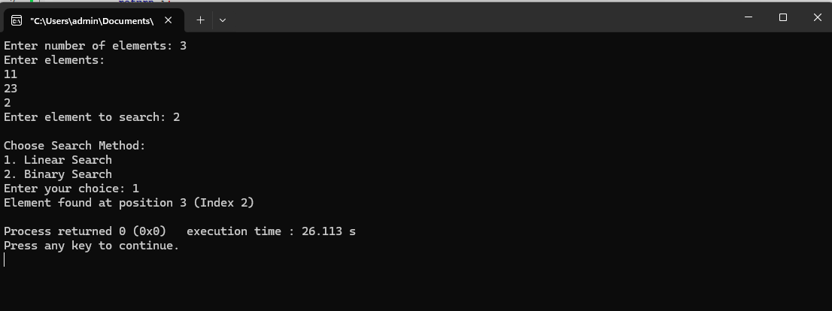
#include <stdio.h>

int main() {
int n, i;

printf("Enter the number of elements: ");
scanf("%d", &n);

int arr[n];

printf("Enter %d elements:\n", n);
for(i = 0; i < n; i++) {
scanf("%d", &arr[i]);
}

int smallest = arr[0];
int position = 0;

for(i = 1; i < n; i++) {
if(arr[i] < smallest) {
smallest = arr[i];
position = i;
}
}

printf("Smallest number = %d\n", smallest);
printf("Position = %d\n", position + 1);

return 0;
}

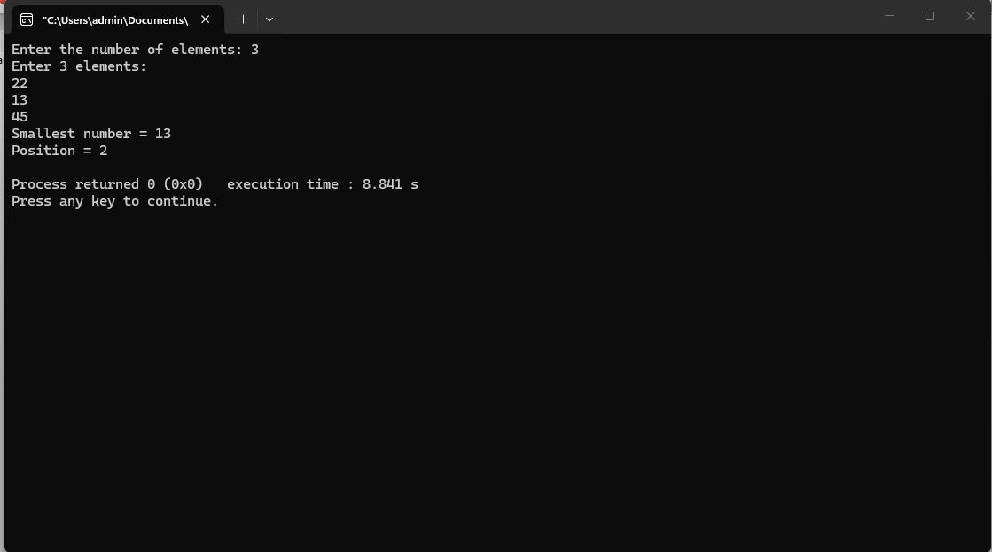
#include <stdio.h>

int main() {
int n, i, j;
int hasDuplicate = 0;

printf("Enter the number of elements: ");
scanf("%d", &n);

int arr[n];

printf("Enter %d elements:\n", n);
for(i = 0; i < n; i++) {
scanf("%d", &arr[i]);
}

// Check for duplicates
for(i = 0; i < n - 1; i++) {
for(j = i + 1; j < n; j++) {
if(arr[i] == arr[j]) {
hasDuplicate = 1;
break;
}
}
if(hasDuplicate)
break;
}

if(hasDuplicate)
printf("Array contains duplicate elements.\n");
else
printf("Array does not contain duplicate elements.\n");

return 0;
}

